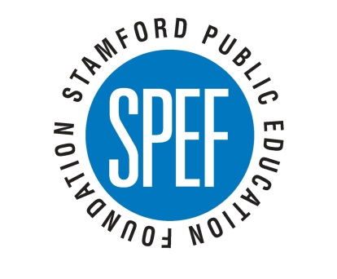
Stamford Public Education Foundation: Our mission is to support the students and teachers in Stamford’s Public Schools (SPS) through community collaboration and philanthropy.

At the elementary school level, we support literacy initiatives and at the middle and high school levels our focus is on college and career readiness. SPEF seeks to provide educational resources and support to children at the low end of the achievement gap.
SPEF was founded in 1996 and received its 501(c)(3) status in 2000. We are a member of the Connecticut Consortium of Education Foundations and the Local Education Foundation Coalitions and we work closely with the local education foundations in Bridgeport, Norwalk, Hartford, and Yonkers.
In 2012, the Connecticut Consortium of Education Foundations sprinted SPEF with the Foundation Celebration Award for the impact we are having on public education in Stamford. In 2014, our Stamford Mentoring Program was one of fifteen mentoring programs nationwide to be selected to participate in the Quality Mentoring Assessment Path (QMAP) conducted by the Governor’S Prevention Partnership. Our mentoring program was rated as a highly effective program which is the top possible rating. SPEF’s Stamford Mentoring Program received an overall rating of 97% for program design and management, operations, and evaluation.
SPEF’s programs are available to all 16,000 Stamford Public Education students, of which 49% of students qualify for free or reduced lunch (a family of 4 qualifying for free lunch earns less than $23,850; a family of four qualifying for reduced price lunch earns less than $44,123).

Grade K-5 Programs | Grade 6-8 Programs | Grade 9-12 Programs
Next Generation  Reading is FUNdamental  Service Learning Mentoring  SPEF Connects  Stamford Mentoring Program | Naviance Family Connection  SPEF Connects  Stamford Mentoring Program | Naviance Family Connection  Scholarships  SPEF Math Tutoring  Success Plan Mentoring  Work Study

Family Literacy Night. Stamford Mentoring Program. Reading is FUNdamental Book Giveaway.

